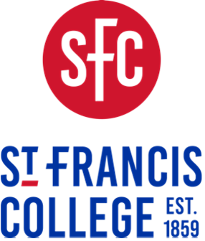
179 Livingston Street, Brooklyn, NY 11201 • Student Accounts • bursar@sfc.edu

Graduation Billing Policy

Effective September 1, 2025, students will not be able to apply to graduate if they have an outstanding bill.
Procedure:
- The Registrar’s office will update the automated response letting students who apply for graduation know that if they have not paid their bill by the graduation application deadline, they will have their application cancelled and will have to postpone their graduation until the next graduation term.

Students enrolled in a payment plan will not be cleared/approved for graduation until their final payment has been received, cleared and fully processed.

- Prior to the deadline to apply for graduation, Student Accounts will communicate to all students that if they have not fully paid all outstanding account balances by the deadline to apply for graduation, they will have to reapply for next graduation term and pay the graduation fee again once their balance is clear.

- After the deadline to apply for graduation has passed, the Student Accounts office will run a list of graduation applicants and place a hold on the accounts of applicants owing money.
NOTE: Registrar will give Student Accounts access to Informer.
NOTE: Student Accounts may need to create a new hold to distinguish from a SA hold.
- Student Accounts will send the Registrar’s office the list of graduation applicants who have outstanding balances.
- Student Accounts will communicate to the students that their graduation application will be cancelled.
- The Registrar’s office will cancel their graduation application of these students.

- Graduation Application open and close dates:
    - Open: First business day for each semester
    - Close: Day after midterms are due for each semester
    - Summer close: First day of Summer Session II

