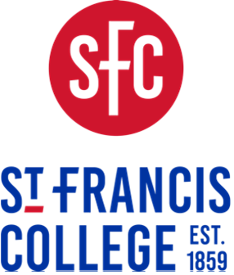

179 Livingston Street, Brooklyn, NY 11201 • Office of Academic Affairs • academicaffairs@sfc.edu

Commencement Policy

Effective September 1, 2025, students will be permitted to participate in the May graduation ceremony (Commencement) if they have satisfied the following conditions:
- The student’s account must be paid in full by the last day of classes in the Spring semester. If full payment is received after the last day of classes in the Spring semester, students will be ineligible to participate in the May graduation.
Students enrolled in a payment plan will not be cleared/approved for graduation until their final payment has been received, cleared and fully processed.
- The student must have completed all degree program requirements, including course requirements by the end of the spring semester prior to May graduation.

Students who complete degree course requirements in a summer semester will only be eligible to participate in the graduation ceremony the following May, assuming they have satisfied all financial obligations to the college.

