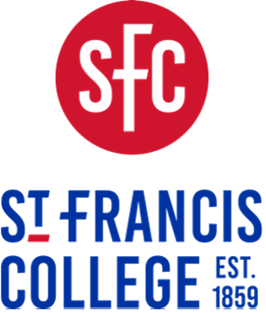
Undergraduate Students

179 Livingston Street, Brooklyn, NY 11201 • Office of Academic Affairs • academicaffairs@sfc.edu

Study Abroad Policy

Effective January 1, 2025, St. Francis College has restructured its Study Abroad Program to follow an entirely external study abroad model. St. Francis College will no longer participate in any study abroad or exchange program with any other college or university which involves sending SFC students abroad. Students wishing to participate in study abroad must identify an external study abroad program through a U.S. college or university, a foreign college or university, or through a third-party provider that fits within the student’s course of study and offers the desired experience.

St. Francis College does not endorse or recommend any foreign university, college, or study abroad agency. St. Francis College will evaluate the external program and courses solely for the purpose of determining whether courses taken will be accepted for transfer credit.

Students will not be eligible for federal or state financial aid, or for institutional aid, to pay for the costs associated with a study abroad program. Students planning to participate in study abroad should apply for outside scholarships to help defray the cost of attendance.

St. Francis College encourages interested students to pursue study abroad. In order to do this, students must observe the following:

  - Students who study abroad during the fall or spring semester must fill out an Institutional Withdrawal / Leave of Absence Form and indicate that the reason for withdrawal is study abroad.

Students who study abroad during the summer will not be required to fill out an Institutional Withdrawal Form.

  - Before commencing courses abroad, students must confirm with the Department of Academic Affairs that the courses are taken at an accredited institution and will transfer back into SFC as transfer credits with a grade of TF. The number of credits to be awarded for any course shall be determined at SFC’s discretion based on a number of factors, including but not limited to the number of credits assigned to the course by the external institution. Courses taken at an external institution may not satisfy a degree program course requirement or satisfy a prerequisite for another more advance course at St. Francis College.

  - Students must sign an acknowledgement and waiver of risk form releasing SFC from responsibility for any losses or other damages that student might incur while they are participating in study abroad. This waiver can be obtained from the Office of Academic Affairs.

  - Students are responsible for determining and obtaining any required visas for their study abroad trip.

  - Students who withdraw from study abroad will not lose access to their institutional aid when they return to SFC.

  - Upon return, students who were required to submit an Institutional Withdrawal / Leave of Absence Form must file for readmission to SFC and submit an official copy of the transcript from the study abroad institution.

  - In order to obtain an undergraduate degree from St. Francis College all students must satisfy the residency requirement of 30 credits.

  - In order to receive credit for courses taken during an external Study Abroad Program, students should have the external institution send the student’s official transcript directly to the following address:

St. Francis College
179 Livingston Street
Brooklyn, New York 11201
Attention: Registrar

Graduate Students
Students in combined undergraduate/graduate degree programs may include courses from abroad in their undergraduate degree. Graduate courses may not be taken abroad.

